 will install 2 dependencies

Import in the main.jsx

import App from './App.jsx'

import './index.css'

import 'bootstrap/dist/css/bootstrap.min.css';

createRoot(document.getElementById('root')).render(

  <StrictMode>

    <App />

  </StrictMode>,

)

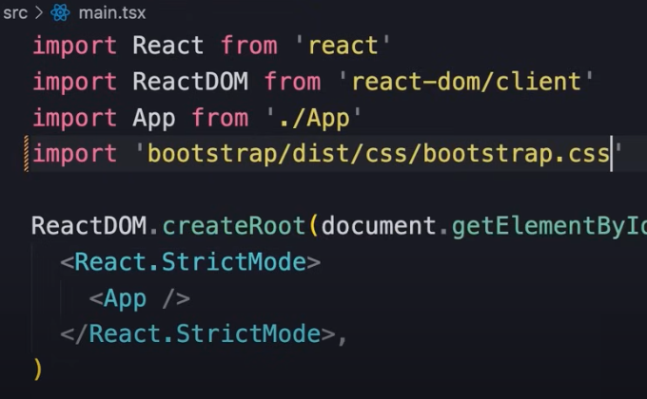

https://react-bootstrap.netlify.app/docs/components

https://react-bootstrap.netlify.app/docs/components/placeholder/#width